Batch: A2 Roll No.: 16010122034
Experiment No. 01
Grade: AA / AB / BB / BC / CC / CD /DD

Signature of the Staff In-charge with date

TITLE : Perfect Number

AIM: Define a class Perfect which accepts the range of numbers from the user. Create a static function check_per , which checks if the number is a perfect number or not and sends the result back to the main function which counts and displays the perfect numbers within that range.

Variations :
Implementation of Program with One class
Accessibility with static and non-static methods within class and outside class.
______________________________________________________________________
Expected OUTCOME of Experiment:

CO2: Explore arrays, vectors, classes and objects in C++ and Java _____________________________________________________________________
Books/ Journals/ Websites referred:

- E. Balagurusamy , “Programming with Java” McGraw-Hill.

- Sachin Malhotra, Saurabh Choudhary, “Programming in Java”, Oxford Publications.
_____________________________________________________________________
Pre Lab/ Prior Concepts:

The Scanner class is a class in java.util, which allows the user to read values of various types. There are far more methods in class Scanner than you will need in this course. We only cover a small useful subset, ones that allow us to read in numeric values from either the keyboard or file without having to convert them from strings and determine if there are more values to be read.

Scanner in = new Scanner(System.in); // System.in is an InputStream
Numeric and String Methods

Method | Returns
int nextInt() | Returns the next token as an int. If the next token is not an integer,InputMismatchException is thrown.
long nextLong() | Returns the next token as a long. If the next token is not an integer,InputMismatchException is thrown.
float nextFloat() | Returns the next token as a float. If the next token is not a float or is out of range, InputMismatchException is thrown.
double nextDouble() | Returns the next token as a long. If the next token is not a float or is out of range, InputMismatchException is thrown.
String next() | Finds and returns the next complete token from this scanner and returns it as a string; a token is usually ended by whitespace such as a blank or line break. If not token exists ,NoSuchElementException is thrown.
String nextLine() | Returns the rest of the current line, excluding any line separator at the end.
void close() | Closes the scanner.

The Scanner looks for tokens in the input. A token is a series of characters that ends with what Java calls whitespace. A whitespace character can be a blank, a tab character, a carriage return. Thus, if we read a line that has a series of numbers separated by blanks, the scanner will take each number as a separate token. .
The numeric values may all be on one line with blanks between each value or may be on separate lines. Whitespace characters (blanks or carriage returns) act as separators. The next method returns the next input value as a string, regardless of what is keyed. For example, given the following code segment and data
- int number = in.nextInt();
- float real = in.nextFloat();
- long number2 = in.nextLong();
- double real2 = in.nextDouble();
- String string = in.next();

Class Diagram:
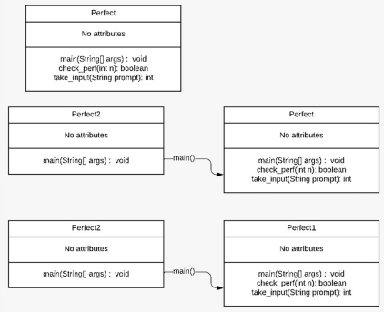

Algorithm:
1. Display “This program will print all perfect numbers in a given range.” 2. Initialize variables “lower”, “upper” and “count”.
3. Start an indefinite loop.
4. Prompt the user to enter the lower limit “lower” of the range.
5. Prompt the user to enter the upper limit “upper” of the range.
6. Set count to 0.
7. For each number "num" in the range [lower, upper]: a. Calculate the sum of divisors "sum" of "num." b. If "sum" is equal to "num," display "num" as a perfect number and increment "count" by 1.
8. Display “Perfect count: “ + count which shows the number(s) which are perfect in the given range.

Implementation details:
- Implementation of Program with One class
import java.util.Scanner;
import java.lang.Math;
public class Perfect {
public static void main(String[] args){

Scanner sc=new Scanner(System.in);
System.out.println("Enter the start of the range");
int start=sc.nextInt();
System.out.println("Enter the end of the range");
int end=sc.nextInt();
sc.close();

int count=0;
for(int i=start;i<=end;i++){
if(check_per(i)){
count++;
System.out.print(i + " ");
}
}
System.out.println("\nTotal perfect no.s in given range : " + count);}

public static boolean check_per(int num){
int sum=1;
for(int i=2;i<=Math.sqrt(num);i++){
if(num%i==0){
sum+=i;
sum+=num/i;
}
}
return num!=1 && sum==num;
}
}

B) Accessibility with static and non-static methods within class and outside class.

B1) Static method in different class:

import java.util.Scanner;
import java.lang.Math;

class Main {
public static void main(String[] args){

Scanner sc=new Scanner(System.in);
System.out.println("Enter the start of the range");
int start=sc.nextInt();
System.out.println("Enter the end of the range");
int end=sc.nextInt();
sc.close();

int count=0;
for(int i=start;i<=end;i++){
if(Perfect.check_per(i)){
count++;
System.out.print(i + " ");
}
}
System.out.println("\nTotal perfect no.s in given range : " + count);
}
}

class Perfect{
public static boolean check_per(int num){
int sum=1;
for(int i=2;i<=Math.sqrt(num);i++){
if(num%i==0){
sum+=i;
sum+=num/i;
}
}
return num!=1 && sum==num;
}
}

B2) Non-static method in different class:

import java.util.Scanner;
import java.lang.Math;

class Main {
public static void main(String[] args){

Scanner sc=new Scanner(System.in);
System.out.println("Enter the start of the range");
int start=sc.nextInt();
System.out.println("Enter the end of the range");
int end=sc.nextInt();
sc.close();

Perfect obj = new Perfect();

int count=0;
for(int i=start;i<=end;i++){
if(obj.check_per(i)){
count++;
System.out.print(i + " ");
}
}
System.out.println("\nTotal perfect no.s in given range : " + count);
}
}

class Perfect{
public boolean check_per(int num){
int sum=1;
for(int i=2;i<=Math.sqrt(num);i++){
if(num%i==0){
sum+=i;
sum+=num/i;
}
}
return num!=1 && sum==num;
}
}

Output:
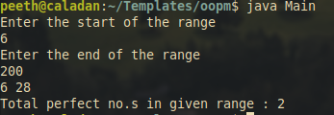
Conclusion:
Learned the basics of java and difference between static and non-static objects as well as various ways to call a program.

Date: 10 August, 2023 Signature of faculty in-charge

Post Lab Descriptive Questions:

Q.1 Write a program to find the area and circumference of a circle using two classes.
Code:
import java.util.Scanner;
import java.lang.Math;

class Main{
public static void main(String[] args){
Scanner sc = new Scanner(System.in);
System.out.println("Enter the radius of the circle:");
int radius = sc.nextInt();
sc.close();
Circle obj = new Circle(radius);
double area = obj.get_area();
double circumference = obj.get_circumference();
System.out.println("Area of Circle: " + area);
System.out.println("Circumference of Circle: " + circumference);
}
}

class Circle{
int radius;

Circle(int radius){
this.radius = radius;
}

double get_area(){
return Math.PI * radius * radius;
}

double get_circumference(){
return Math.PI * 2 * radius;
}
}

Output:
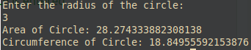
Q.2 Write the output of following program
- public class BreakExample2 {
- public static void main(String[] args) {
- //outer loop
- for(int i=1;i<=3;i++){
- //inner loop
- for(int j=1;j<=3;j++){
- if(i==2&&j==2){
- //using break statement inside the inner loop
- break;
- }
- System.out.println(i+" "+j);
- }
- }
- }
- }

Output:
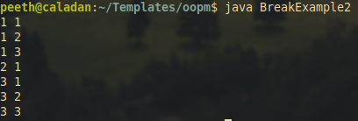

Q.3 Why is Java known as a platform independent language?
Java is called platform-independent because it uses a special middleman called bytecode. Instead of directly translating code into machine language, Java turns it into bytecode. Then, a tool called the Java Virtual Machine (JVM) converts this bytecode into machine-specific instructions, allowing Java programs to run on different types of computers without changes.

Q.4 Write a recursive static method for calculation of gcd of a number.
public static void gcd(int a,int b) {
if (b == 0) {
System.out.println("GCD is " + a);
}
else {
gcd(b, a % b);
}
}

